MAY 2026

Susquehanna Valley Ministry Center

I recently attended the spring governing board meeting for the Susquehanna Valley Ministry Center (SVMC), a board that I serve on as part of my role as your District Executive Minister. SVMC is a partnership of five districts: Atlantic Northeast, Southern Pennsylvania, Middle Pennsylvania, Western Pennsylvania, and our district.
This partnership provides many educational opportunities for members of the five districts, and it runs the joint Academy Certified Training System for our five districts. This is one of the educational tracks that licensed ministers can choose as they work towards ordination or commissioning.
SVMC also offers many continuing education opportunities for our ordained and commissioned ministers as they keep up with their requirements for continuing education. These offerings also give our credentialed ministers opportunities to interact with ministers from across our District and the other districts in the partnership, building up the connections that are so important for our ministers as they do their work in our local congregations.
Last year, SVMC hired a new Executive Director, Audrey Hollenberg-Duffey from the Oakton congregation. Since taking on the role, she has been working hard to bring new offerings and ways of doing education to SVMC.
Many new, exciting opportunities will be coming out of SVMC over the coming months and years. I encourage everyone in our District to check out their website to find educational opportunities to engage and to support the ongoing work of SVMC. It is a wonderful organization that we partner with to deliver education to our District. (Information about SVMC may be found at this link: Susquehanna Valley Ministry Center | Elizabethtown College .)
In Christ,
Doug Veal,
District Executive Minister

Opportunity to Virtually Attend Annual Conference for Free!

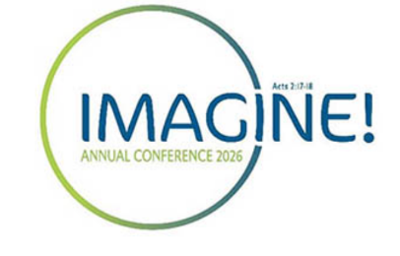
Thanks to generous contributions from the Living Stream Church of the Brethren (COB) and the Pacific Northwest District (PNWD), COB is able to offer the virtual option to attend the 2026 Annual Conference at no charge. This gives non-delegates the opportunity to engage in business, participate in a number of equipping sessions, and enjoy the Wednesday evening concert featuring Brethren musicians—all virtually. All virtual participants must still register between March 4 and June 23. Virtual attendees are encouraged to make a donation to Annual Conference as an expression of appreciation. Go to Registration – Annual Conference and select Virtual Non-Delegate Registration.
This is an opportunity for all those who might wish to attend conference, yet cannot swing it logistically or financially, to still participate. It also gives those who might wonder what Annual Conference is really all about a chance to actually take a peek and join in, without committing a week for travel and hotel and meal costs. People can join for a session or two, attend worship services, watch the concert, and also have access to the recordings of all those events. (Please note that anyone can watch only the worship services for free without this virtual registration option.)
Why this is important: Our goal is to unite the church, increasing communication and fellowship across the denomination, by opening it up to as many people as possible by removing barriers to virtual access. Further, if virtual attendance is high, we will have demonstrated that there is indeed a desire across the denomination to continue providing virtual access to Annual Conference, and so it will become more accessible. Yet the opposite is also true: if virtual attendance is low, we will have learned that making Annual Conference accessible in this way may not be worth the effort in its current form.
We're trying to get the word out, because we hope that every Brethren will be able to consider this invitation. We would be delighted for more folks to participate in Annual Conference, whether in person or virtually!

Spotlight on Marcia Sowles

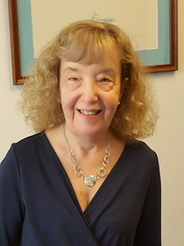
Church home: Arlington Church of the Brethren, Arlington, VA
Personal background: Marcia Sowles is a long-time member of the Arlington COB. Her Brethren background, which goes back to her childhood, includes earning her undergraduate degree at Manchester University. She has served her local congregation as a Board member and as an active member of its service team; she also served as a representative on the Mid-Atlantic District (MAD) Leadership Team for several years.
In addition to her bachelor’s from Manchester, she has a Juris Doctor degree from Valparaiso University School of Law in Indiana and a Master of Laws from Yale Law School. From September 1987 to January 3, 2025, she was a trial attorney with the Civil Division of the U.S. Department of Justice (DOJ), where she represented federal agencies in litigation. She was a trial attorney with the U.S. Department of Energy from 1980 to 1987 and an attorney with the Legal Services Program of Northern Indiana for four years.
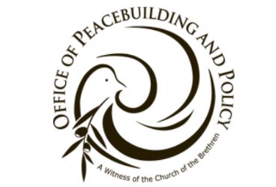
Volunteer Position Highlights: When Sowles retired from DOJ in January 2025, she still wanted to do something to help others and thought a great deal about where she might be effective. Because Sowles lives in the Washington Metropolitan Area, she decided to look into what Nate Hosler is doing at the Office of Peacebuilding and Policy. She said, “I talked to Nate about a potential role, and at that time immigration issues were gaining in importance, both within the COB churches and the broader community.” Sowles joined the COB’s Office of Peacebuilding and Policy in Washington, D.C., where she currently volunteers as a Legal Advisor and Policy and Governmental Affairs associate. She focuses primarily on immigration policy and also provides legal updates on environmental issues and constitutional and international law issues related to the Executive Branch’s use of military force.
Sowles has participated in this role in a wide variety of ways. She seeks to assist COB churches who have immigrant members; has worked with District Executive Ministers who have identified churches who need assistance; and participated in a workshop at the 2025 Annual Conference called “Walking by Faith; Caring for Immigrants in Our Community and Our Call to Embody Love.”
Currently, Sowles is following immigrant case law, how people continue to be affected, and how COB can help. For example, she accompanied a Maryland church group of Methodists and Quakers when they attended a Congressional meeting. She finds that she now spends 30 or more hours a week on issues related to this new volunteer position.
Sowles will be involved in the upcoming Annual Conference in Fort Wayne, IN. Along with others from the Office of Peacebuilding and Policy and Intercultural Ministries, they will provide updates on advocacy around immigration issues, including legal updates on key cases, know-your-rights resources, and exploring the connection to growing U.S. militarism. For those of you who will be at the 2026 Annual Conference, you can attend the workshop to be held on Monday, June 29, at 12:30 pm.
The COB Office of Peacebuilding and Policy works in Washington, DC to advocate for Brethren values including peace and nonviolence, welcoming immigrants, and environmental justice in the context of U.S. policy. You can find out more about their activities at the following link: Office of Peacebuilding & Policy website.
Gretchen Zience, Communications Ministry Team
Bethany, ACTS, SVMC, and TRIM…Oh My!

There are a lot of letters in the title of this article, but what does it all mean? In one word, Opportunity! Most of us are aware of Bethany Theological Seminary; however, how many people realize that most of the degrees offered there are not centered around ministerial licensing or ordination? For example, three people in MAD graduated this year. One graduated with a Master of Divinity, one with a Master of Arts: Theopoetics and Writing, and yours truly with a Master of Arts: Spiritual and Social Transformation with a focus on non-profit leadership.
The Susquehanna Valley Ministry Center (SVMC), housed at Elizabethtown College, provides access to the Training In Ministry (TRIM) program for individuals who are interested in vocational ministry and need a flexible training program. SVMC is also the local home to the Academy Certified Training System (ACTS), a collaborative effort between Bethany Theological Seminary and the COB’s Missions and Ministry Board, for those interested in vocational ministry, but who can’t enroll in the Master of Divinity (MDiv) program at Bethany because of work and/or family.
Beyond the opportunities I’ve mentioned above, the Brethren Academy for Ministerial Leadership (which is responsible for ACTS and TRIM) also offers a program called Education for a Shared Ministry (EFSM), which trains those who may not want to be a Senior Pastor but who want to take on a specialized ministry role and work with lay leaders. Bethany also offers eight different graduate-level certificate programs that can be completed in one or two years each for those who wish to expand their knowledge and skills.
While these programs are easily accessible, they are easily overlooked. Many current MAD pastors, ministers, and lay leaders have been trained through one or more of these programs. The COB offers ample opportunity for anyone who wishes to further their education, whether your end goal is vocational ministry or not. More information is available on the Bethany and SVMC websites. Happy learning!
Adam Lane, Communications Ministry Team
Mid-Atlantic District Older Adult Retreat

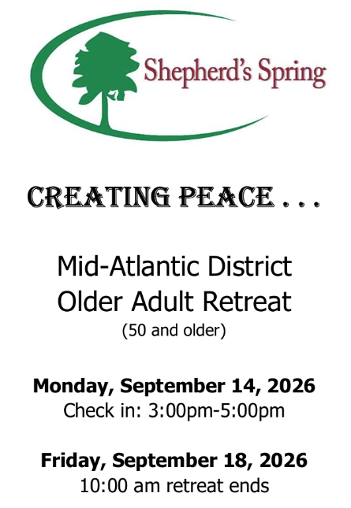
For the first time ever, a retreat will be held for older adults 50+ in the MAD! You don't want to miss this opportunity to fellowship, worship, learn, serve, relax, and rejuvenate at the Mid-Atlantic District Older Adult Retreat at Shepherd's Spring on September 14-18, 2026. With the theme, “Creating Peace,” the retreat will explore creating peace with our neighbors, creation, and ourselves. Each day will offer a presentation along with many activities from which to choose. Three resource leaders will explore the following topics:
- Creating Peace with Neighbors, led by Phyllis Dodd
- Creating Peace with Creation, led by Doug Ruby
- Creating Peace with Ourselves, led by Judith Clister
Music leaders will be Phyllis Dodd and Rusty Curling.
Register at https://shepherdsspring.campbrainregistration.com/. You can obtain a brochure that provides all the retreat details by contacting the District office at AAMAD@brethren.org. Come and experience the peace of creation at Shepherd's Spring!
Deacon Training Held at Mountain View

Mountain View COB hosted a regional Deacon training workshop titled “Deacons: Called to Care” on April 25 with Dr. Jim Benedict facilitating the training. The four-hour workshop was attended by Deacons from Mountain View, Moler Avenue, Brownsville, and Thurmont. Regional Ministry Associate, Charlotte Bear, also attended.
Dr. Benedict covered topics that included a scriptural and historical review of the Deacon Ministry as well as practical ways Deacons provide care for congregations. The workshop was informative and provided an opportunity for Deacons to share their experiences with one another.
Lane Hired as Program Assistant for Children’s Disaster Services


Adam Lane begins May 27 as program assistant for Children’s Disaster Services (CDS), a ministry within Brethren Disaster Ministries. He will work from the Brethren Service Center in New Windsor, MD. Lane graduated from Huntington University with a bachelor’s degree in Worship Leadership. He also received an M.A. in Spiritual and Social Transformation from Bethany Theological Seminary. He brings knowledge of technology, social media, newsletter writing, data filing, and event planning to the work. He and his family are members and regular attendees at Beaver Creek COB in Hagerstown, MD.
Profile of Miller Davis

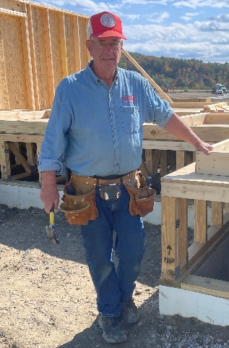
Editor’s note: This interview by Louise Scalzi is being published in two parts; the second half will be in the July Journey newsletter.
I have known Miller Davis for many years as an active member of the Westminster COB congregation. Recently I had the opportunity to attend a Brethren Disaster Ministries trip to Eastern Kentucky with a group that he organized for the week. I was especially impressed by his leadership skills. I had also seen him in action recently, as he organized, planted, and nurtured the new, grant-funded small community garden at our church. Seeing him most weeks at Sunday School and other church activities, he seemed to be not only a member of many groups, but clearly a leader in our church and denomination. In times when good leaders are hard to find, I wondered how he is able to serve and lead in so many positive ways. What follows is an interview with Miller to find out.
Louise: Tell me generally about yourself.
Miller: I was born in 1943, in Rockingham County, VA and graduated from high school there. My father died when I was 11 years old, so I began to assume more responsibility in my home at a young age. I began working on my uncle’s farm and grandfather’s farm when I was 10 years old. I got my Social Security card there and had my first public job working for the city of Harrisonburg, VA, mowing grass. I worked my way through college as a laborer at a company in nearby Broadway, VA.
I graduated from Bridgewater College, and in 1965 I entered BVS in New Windsor. My first position with them was to serve on the orientation staff. After completing BVS, I returned to Virginia and worked as a supervisor for Lantz Construction Co. for the next four years. In summer 1971, I was recruited to oversee the renovation of Old Main in the Brethren Service Center. I continued to work at the Center for a total of 27 years! At the age of 28, I had started a tape in my head that I wanted to retire at the age of 55 and do something else. On my 56th birthday I started driving a school bus for Carroll County and drove motor coaches for several years. In February 2002, I was called to serve as the interim administrator at Sheperd’s Spring Outdoor Ministry Center. I served for just shy of a year and found that it really used my gifts. Even though I knew nothing about running a camp, I had other people to oversee the program part, and I was charged with the administration, which I could and wanted to do. I then served as the interim Heifer International Vice President of External Relations. During that time, I commuted to Little Rock, AR for seven months.
Louise: Which experiences have helped to shape your life the most?
Miller: Being born into a family of COB members. I have two older sisters and a younger sister who is deceased. I have continued going to the COB for 83 years. That has certainly been a shaper. In 1962, I went to National Youth Conference in Colorado. Chuck Boyer, director of BVS at the time, appealed to us and challenged us to make a commitment to serve in BVS. I did that and with that decision, the needs and opportunities throughout the world came alive to me. During my time with BVS, I also decided to fulfill my military obligation as a conscientious objector. I had already met Dan West and Mr. Ziegler when I was a child, but BVS was an opportunity to meet more leaders like Don Snyder and Fran Nyce who were active in the denomination and my home church.
Another life-shaping experience was growing up on a 12-acre farm. My father’s death was sudden, and I had to learn how to work well and hard. I have always been blessed to work with really fine people. At a time before there was a special outreach disaster program, I worked with Mac Coffman and Ken McDowell in that area when needed. When Buffalo Creek slag dam burst in West Virginia, Mac took me to the site to see how Brethren might be able to respond in a helpful way. I ultimately oversaw the work of our disaster response in Forty Fort, PA. I was full into my responsibilities and would be away from home a lot. The Johnsville flood of 1977 was my last project. This was also during the time that full-time leadership of the disaster response was needed, and it was the beginning of the Brethren Disaster Ministries as we know it today.
Having an opportunity to serve on the Heifer International Board and then, later, the Heifer Foundation Board gave me another avenue to engage with ecumenical leaders and hear how other denominations saw the COB’s part in it. It was hard not to be proud that our own Dan West had started the Heifer Project. I felt really privileged to serve as the chair of the Heifer International board during its 50th anniversary. I dealt with lots of difficult challenges, but I learned it is important that when you have gut feelings about an agenda and something in particular as you are moving along, it needs to be expressed.
Lastly, during BVS orientation, when Dan West spoke to the volunteers, he expressed that, “The world suffers from a lack of acceptable alternatives.” I have used that as a manager. When people who reported to me came with issues, I’d say, “Okay, what are the acceptable alternatives?” I still use that currently with my wife during our decision-making processes.
I also follow the “one-minute manager” style (described in Ken Blanchard’s book), which underscores the value of making sure that others--employees, children, community members--are clear about the expectations and/or requirements of an assignment and then the importance of the movements needed to obtain them. It requires honest, positive dialogue, feedback, and checking in when others are struggling.
Louise: You seem very disciplined, organized, creative, and visionary in surveying a new challenge or problem. Is that a correct perception of your approach to leadership?
Miller: Probably yes. I don’t know where this came from, but give me a space and tell me what you want to put in it, and I can visualize that pretty quickly. I am not afraid to ask the “what-if” questions. In fact, when I retired one of my gifts from my office staff was a t-shirt with “What If” in bold blue letters on it.
Louise: What have been your connections to the COB over the years?
Miller: I was born into a family of more than five generations of Brethren. My ancestors are buried in our own church’s cemetery. I am married to Connie Davis and together we have four children and six grandchildren. They all help to keep me grounded. I’ve served on the board/leadership team as chair and as a member a couple of times. I’ve been on the finance and witness teams. I started, along with Bruce Darsch, a small group to help members of the church community with home projects. I have served two five-year terms on the Bethany Seminary board. Being a part of the church community is more than just Sunday. It was that way in my home growing up. My mother let me know that I needed to behave myself; I’m certain that I disappointed her at times but, anyway, I have tried!
Louise Scalzi, Communications Ministry Team
News Around our District

Congregational Openings, Placements, Updates | Upcoming District Events
Bethany—Profile circulating; Jerry Fike interim  Denton—Profile circulating; pulpit supply  Fellowship—No profile available; Brad Webbing interim  Hagerstown—Profile circulating; Twyla Rowe retiring May 31, 2026; Eddie Edmonds to serve as interim  Harmony—Profile circulating; Leon Yoder interim  Moler Avenue—Profile circulating  Washington City—Profile available; searching for part-time pastor  Welty—Profile circulating; Gideon Elliott interim  Westminster—No profile available; Sandi Evans Rogers interim  Woodbridge—No profile available; Charlotte Bear interim | Jun 12-14—2026 District Youth Retreat/Camp Get-Away, Shepherd’s Spring Outdoor Ministry Center; additional details and the registration link can be found at https://www.shepherdsspring.org/camp-info  Jun 18—MAD Annual Conference Delegate Briefing, 7 pm to 8:30 pm; zoom link to be distributed  Jun 28-Jul 2—2026 Church of the Brethren Annual Conference, Fort Wayne, IN  Sept 14-18–MAD Older Adult Conference, Shepherd’s Spring Outdoor Ministry Center  Oct 9-10—MAD District Conference, Camp Mardela, Denton, MD  Oct 23—2026—Pastors’ Retreat, sponsored by MAD Spirituality and Congregational Life Ministry Team  The District office sends out flyers to all churches that describe many of these upcoming events. Check with your church office or contact the District if you would like additional information (aamad@brethren.org).

Mid-Atlantic District  Church of the Brethren  19 Bond Street  Westminster, MD 21157  443-960-3052  Douglas Veal, District Executive Minister  dveal@brethren.org  Jo Ann Landon, Administrative Assistant  aamad@brethren.org | Please submit items for The Journey newsletter to Jo Ann Landon in the District Office.  Permission is granted by the  Mid-Atlantic District to reproduce and distribute  information from this newsletter.

