*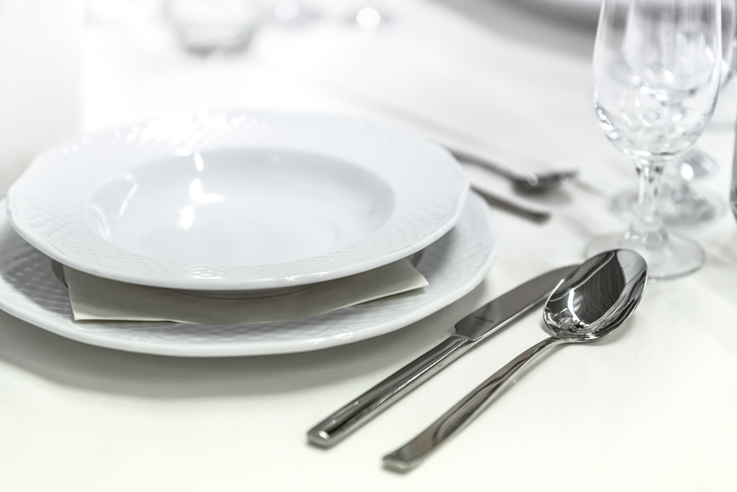You and a guest are invited:*

***Mid-Atlantic District***

***Minister & Spouse Dinner***

***Friday, October 10, 2025***

***5:30 p.m.***

***Thank you to the Part-Time Pastor/Full-Time Church program***

***for sponsoring this dinner!***

*Union Bridge Church of the Brethren*

*124 S. Main St., Union Bridge, MD 21791-0518*

***Dinner prepared and served by Grossnickle Church of the Brethren***

***RSVP by September 17*** *to the email or mailing address below*

*Mid-Atlantic District Office*

*19 Bond St., Westminster, MD 21157 ⚫ 443-960-3052 ⚫* [*aamad@brethren.org*](mailto:aamad@brethren.org)

**Mid-Atlantic District 2025 Minister & Spouse Dinner**

*Union Bridge Church of the Brethren Friday, October 10, 2025 5:30 pm*

|  |
| --- |
|  |

Name(s)

|  |
| --- |
|  |

Contact Info

***Please continue to page 2 to select your menu item***

We would like to request childcare during the dinner (please complete a [Childcare Registration Form](http://www.madcob.com/wp-content/uploads/2025/07/Childcare-Registation-2025.pdf) and an [Emergency Contact Treatment and Waiver form](http://www.madcob.com/wp-content/uploads/2025/07/Emergency-Contact-Treatment-and-Waiver-Form-2025-Fillable.pdf).

***Minister and Spouse Dinner***

*Friday, October 10, 2025 5:30 pm*

*Union Bridge Church of the Brethren*

Please make your dinner selections for you and your guest and return this form to

*Mid-Atlantic District Office*

*19 Bond St., Westminster, MD 21157 ⚫* [*aamad@brethren.org*](mailto:aamad@brethren.org)

|  |
| --- |
|  |

**Name**

Please select one entrée: Applewood Grilled Salmon (GF)

London Broil (GF)

Mild Curry Dish with chickpeas, cauliflower and veggies

(GF/Vegan)

Along with your entrée, your dinner will include rice pilaf, roasted potatoes, salad, bread and a

selection of desserts.

|  |
| --- |
|  |

Special Dietary Needs

|  |
| --- |
|  |

**Guest**

Please select one entrée: Applewood Grilled Salmon (GF)

London Broil (GF)

Mild Curry Dish with chickpeas, cauliflower and veggies

(GF/Vegan)

Along with your entrée, your dinner will include rice pilaf, roasted potatoes, salad, bread and a

selection of desserts.

|  |
| --- |
|  |

Special Dietary Needs